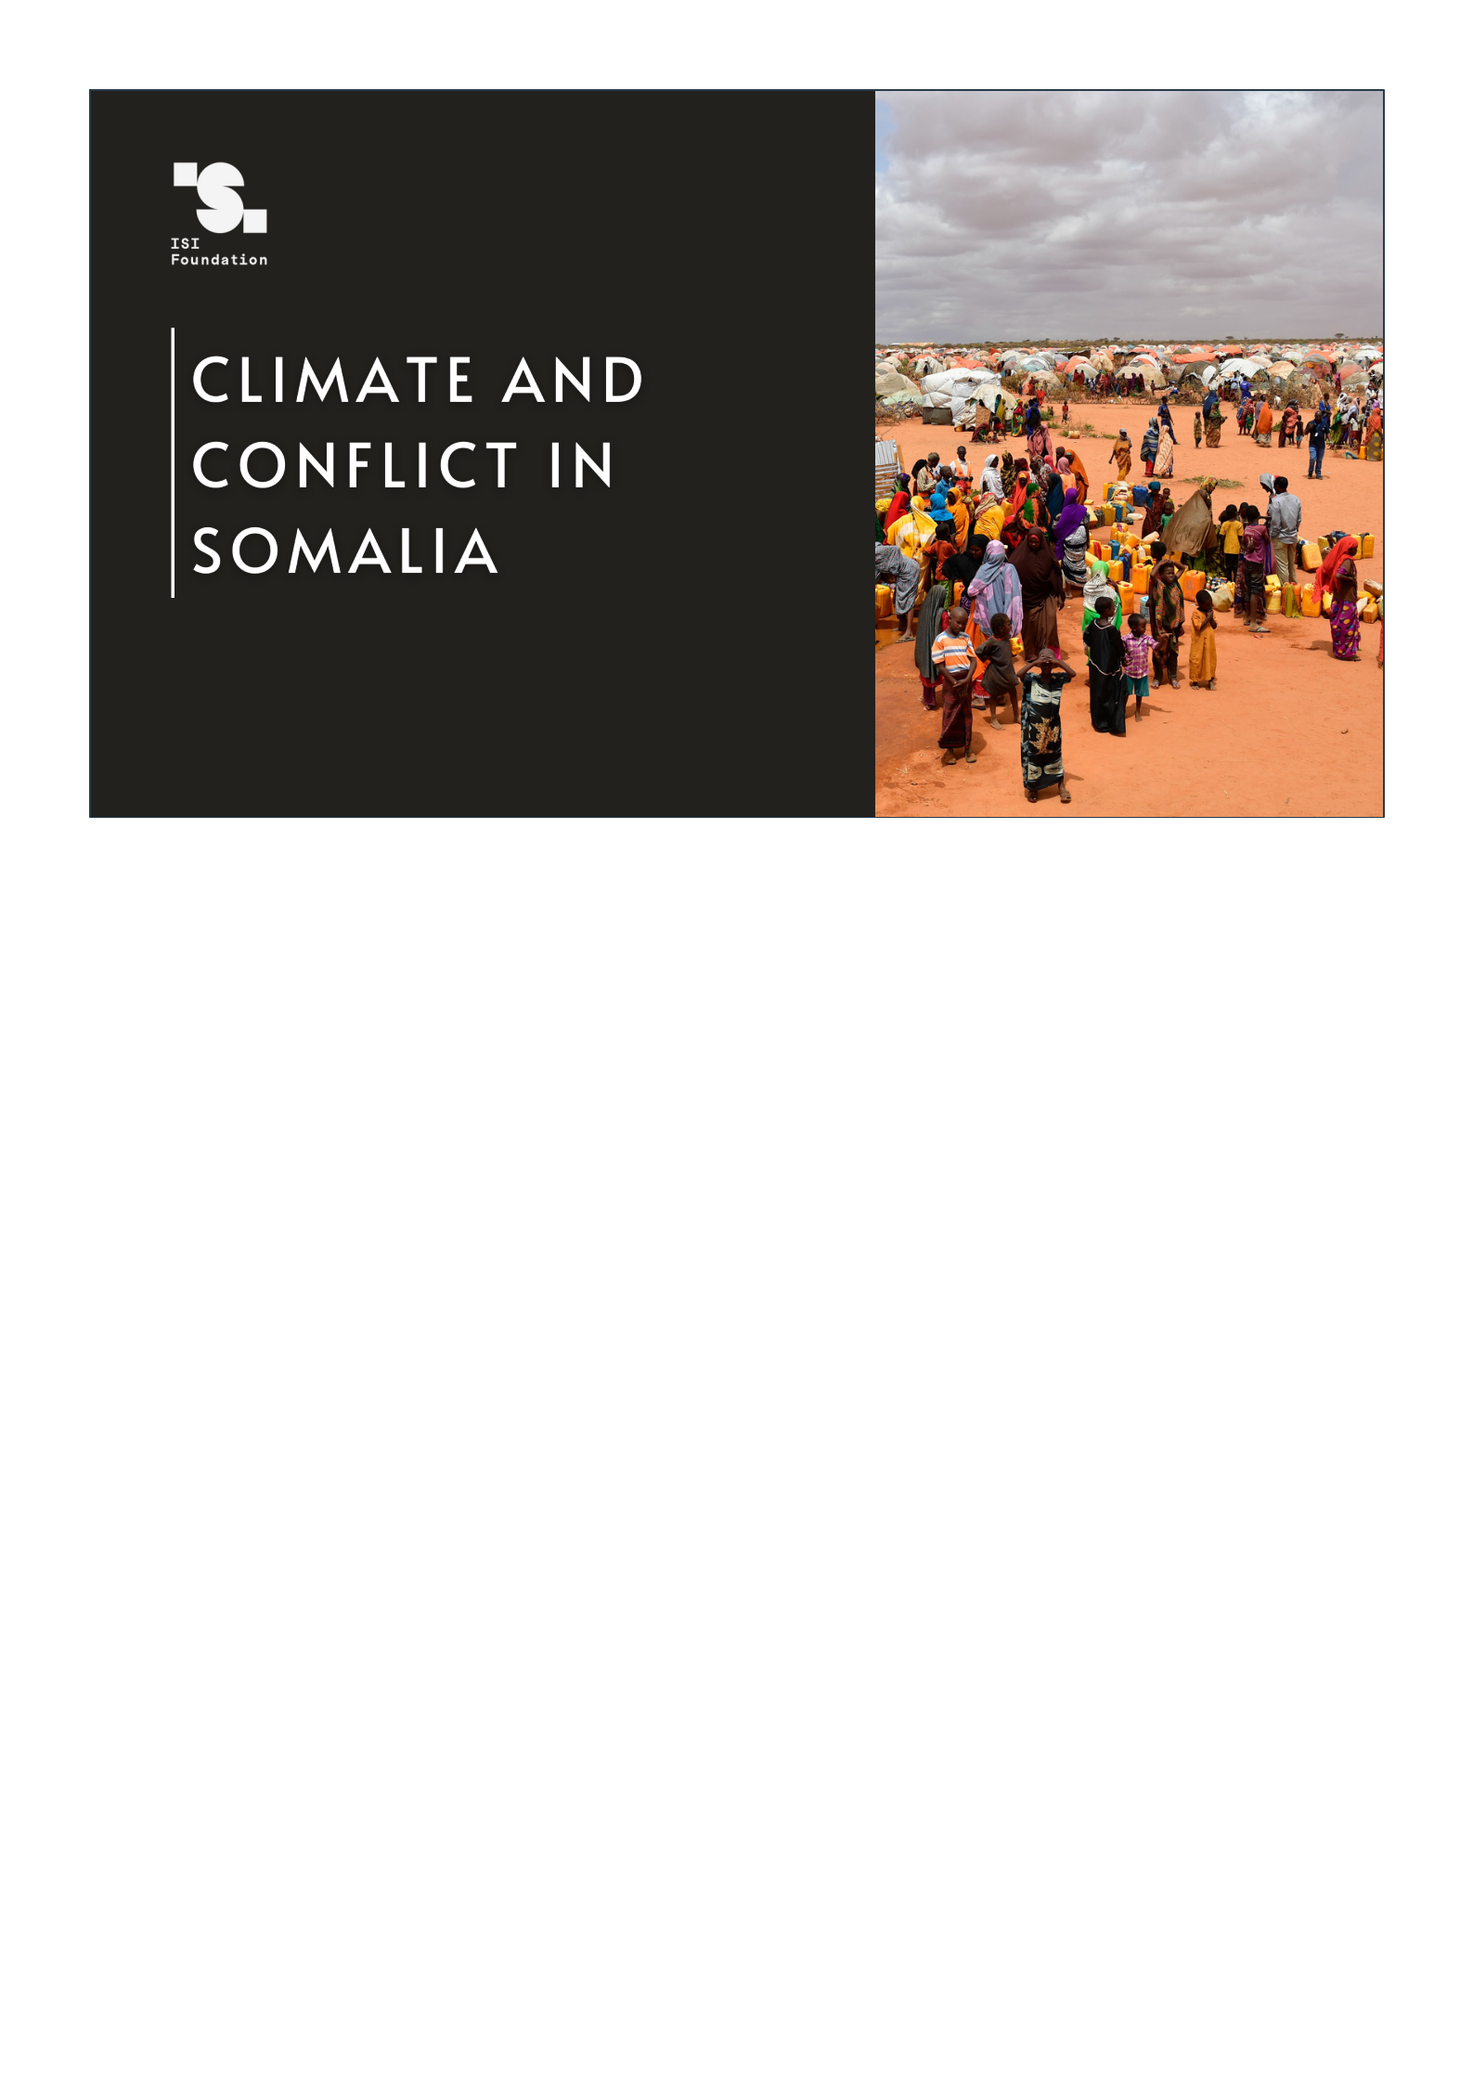

Sara Ghivarello

Climate and conflicts in Somalia Pagina 1 di 12

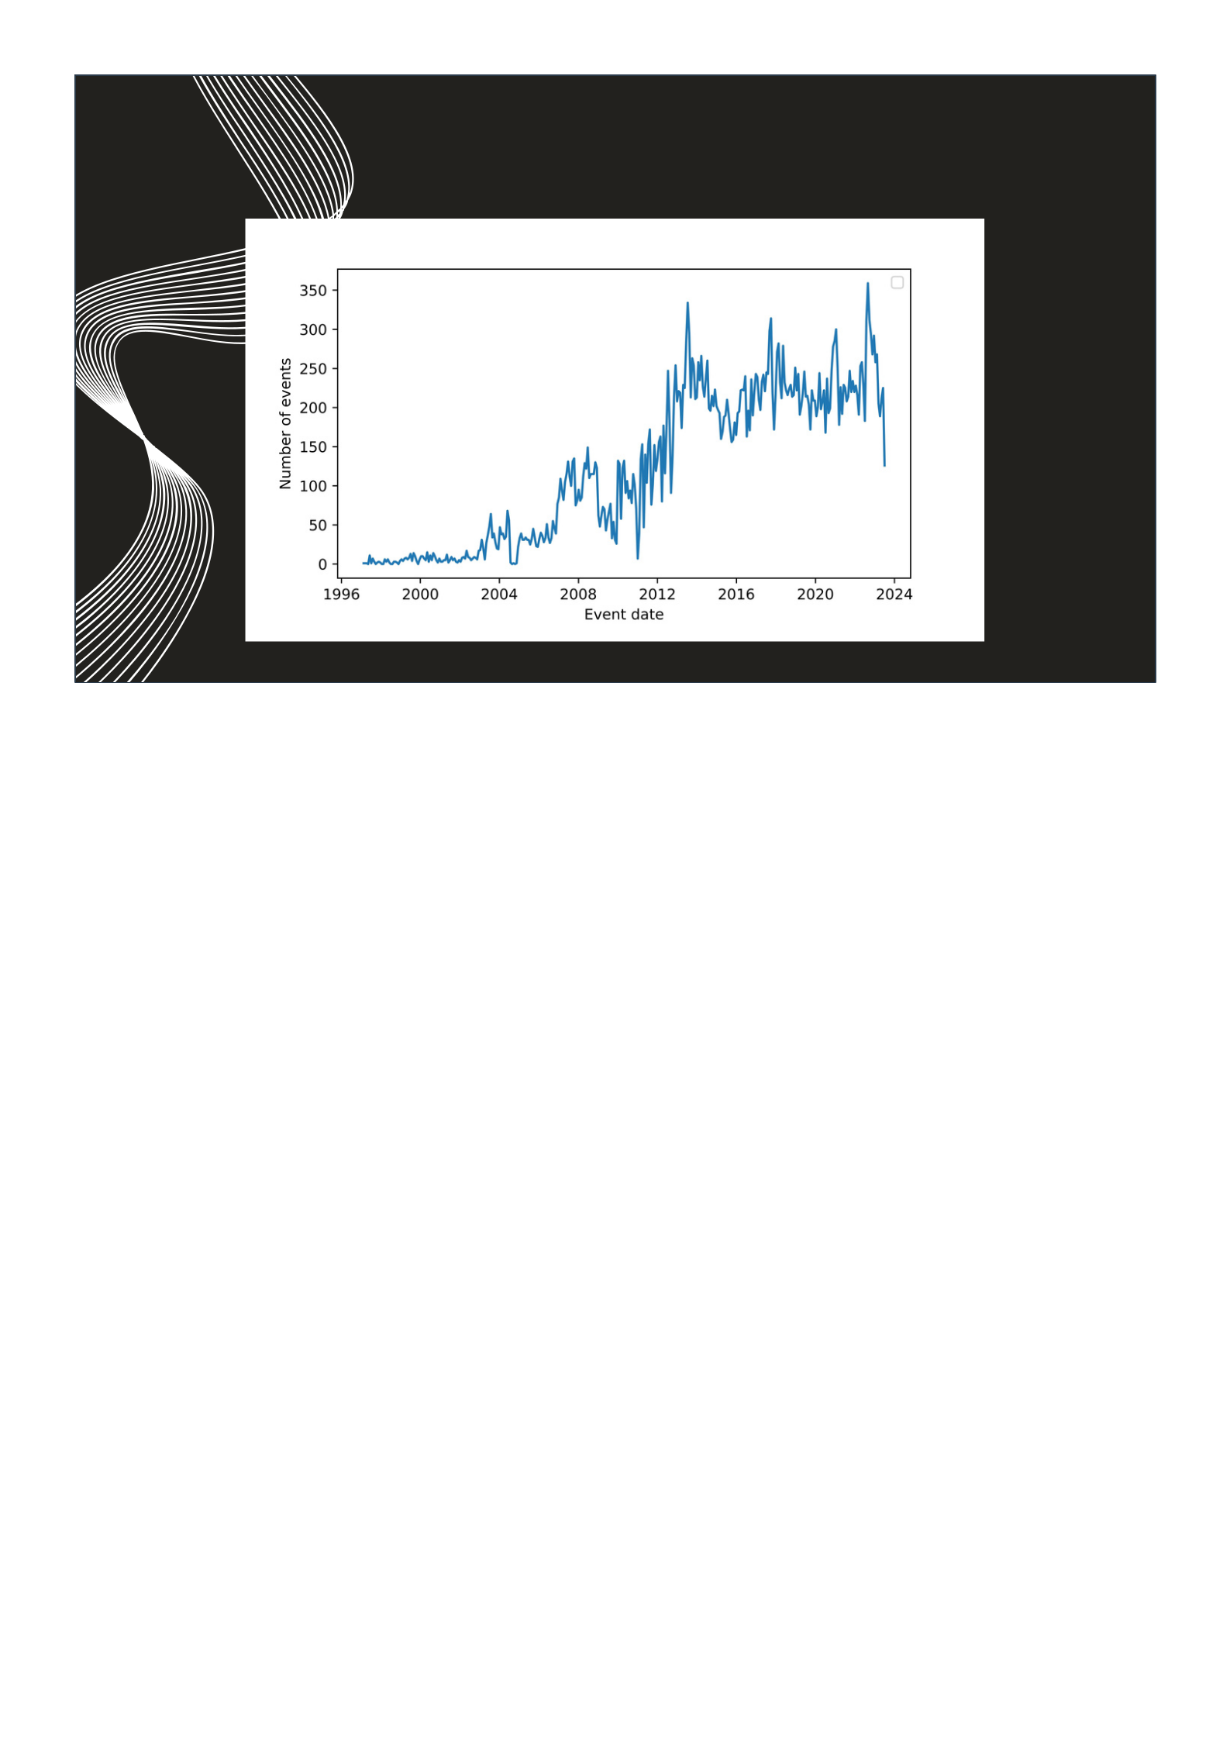PROTESTS AND VIOLENT EVENTS

Climate and conflicts in Somalia Pagina 2 di 12

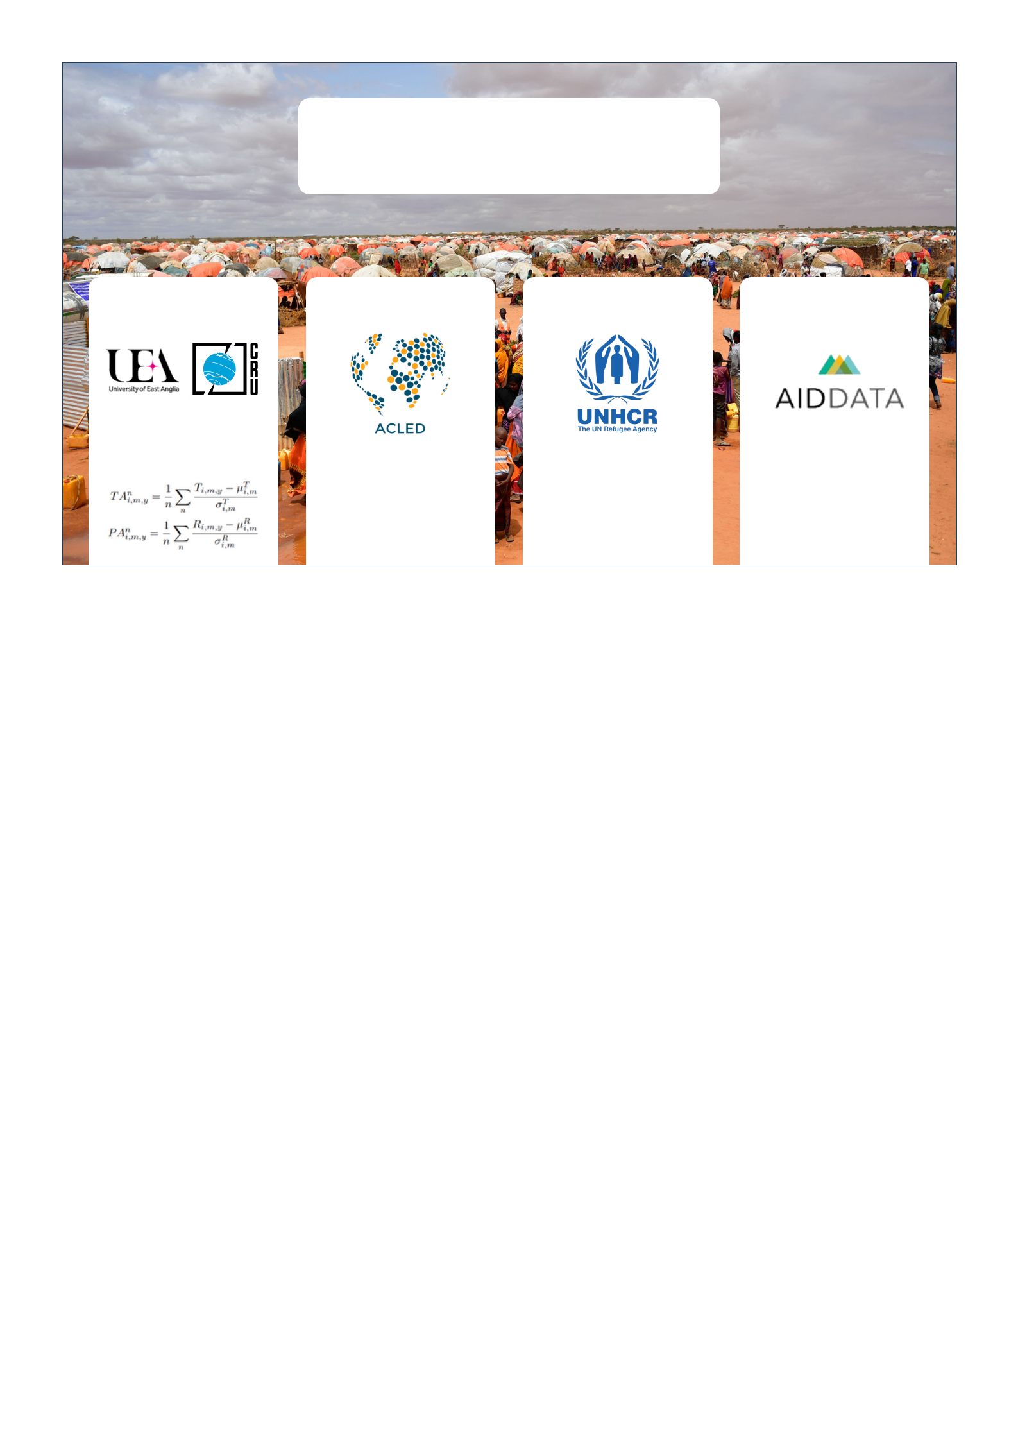

**DATA**

|  |  |  |  |  |
| --- | --- | --- | --- | --- |
| Climate | Conflicts | Displacements | Control |  |
| Timeseries dataset of |  |  |  |  |
| gridded temperature |  |  |  |  |
| and precipitation | Protests and violent | Protection and | GDP and |  |
|  | events at a sub- | Return Monitoring |  |
|  | population density |  |
|  | national level, | Network (PRMN) |  |
|  |  |  |
|  | grouped per month | survey |  |  |

Climate and conflicts in Somalia Pagina 3 di 12

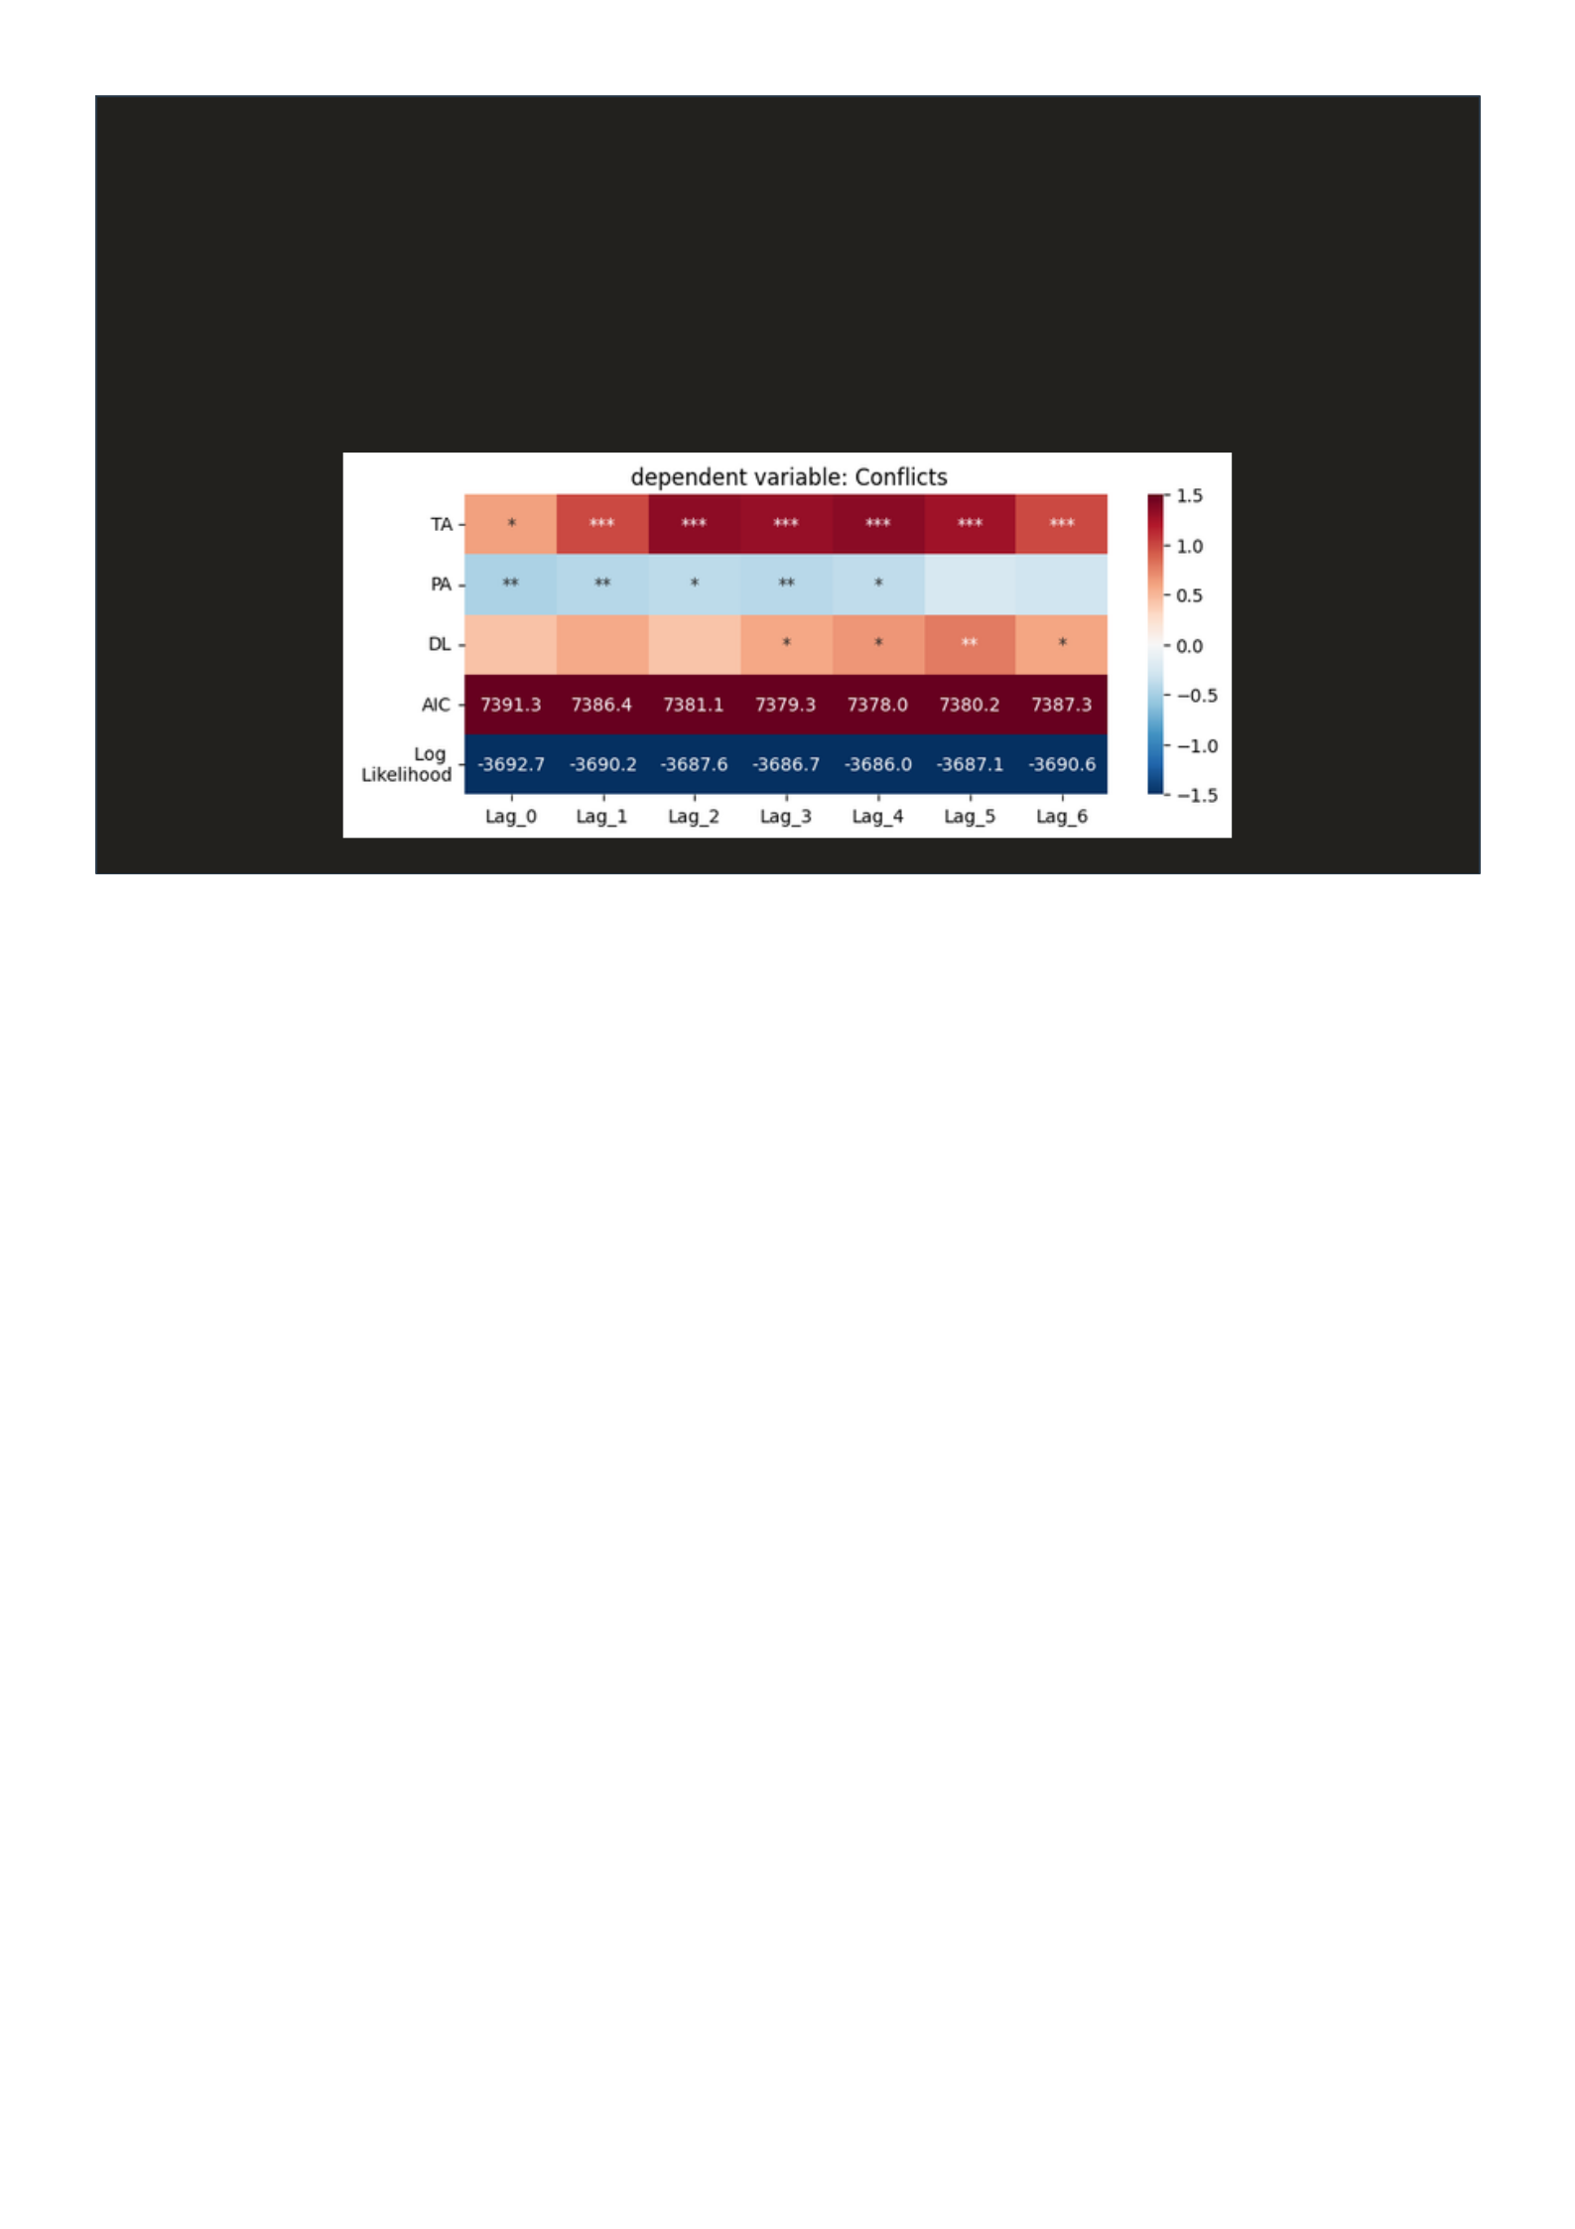LINEAR MODEL 1a

Temperature anomalies TA

Conflicts Precipitation anomalies PA

∝ Drought lenght DL

Climate and conflicts in Somalia Pagina 4 di 12

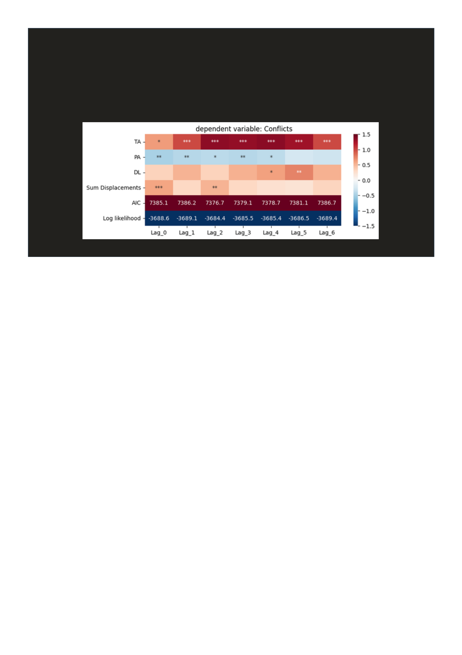LINEAR MODEL 1b

Add the number of displacements arriving to the region

Climate and conflicts in Somalia Pagina 5 di 12

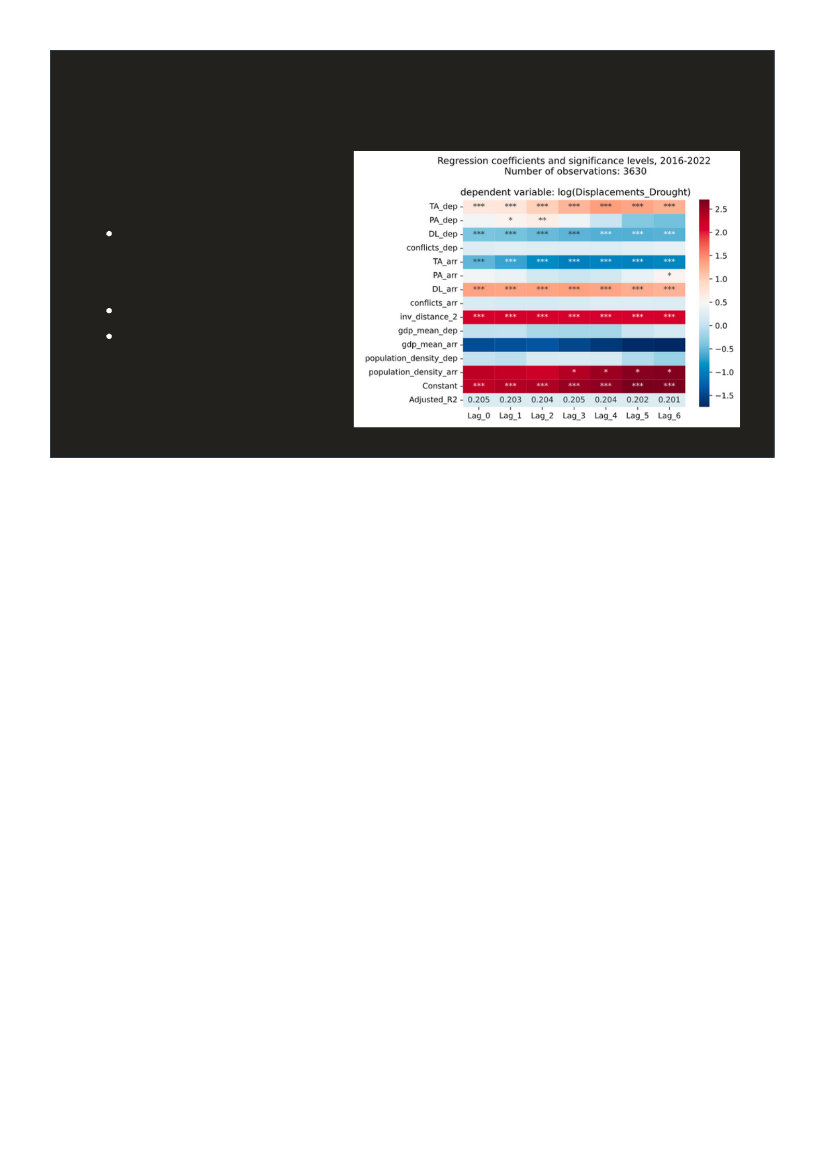LINEAR MODEL 2

Log (Displacements)

∝

Climate and conflict variables in the departure and arrival regions, inverse distance^2, control variables

Climate and conflicts in Somalia Pagina 6 di 12

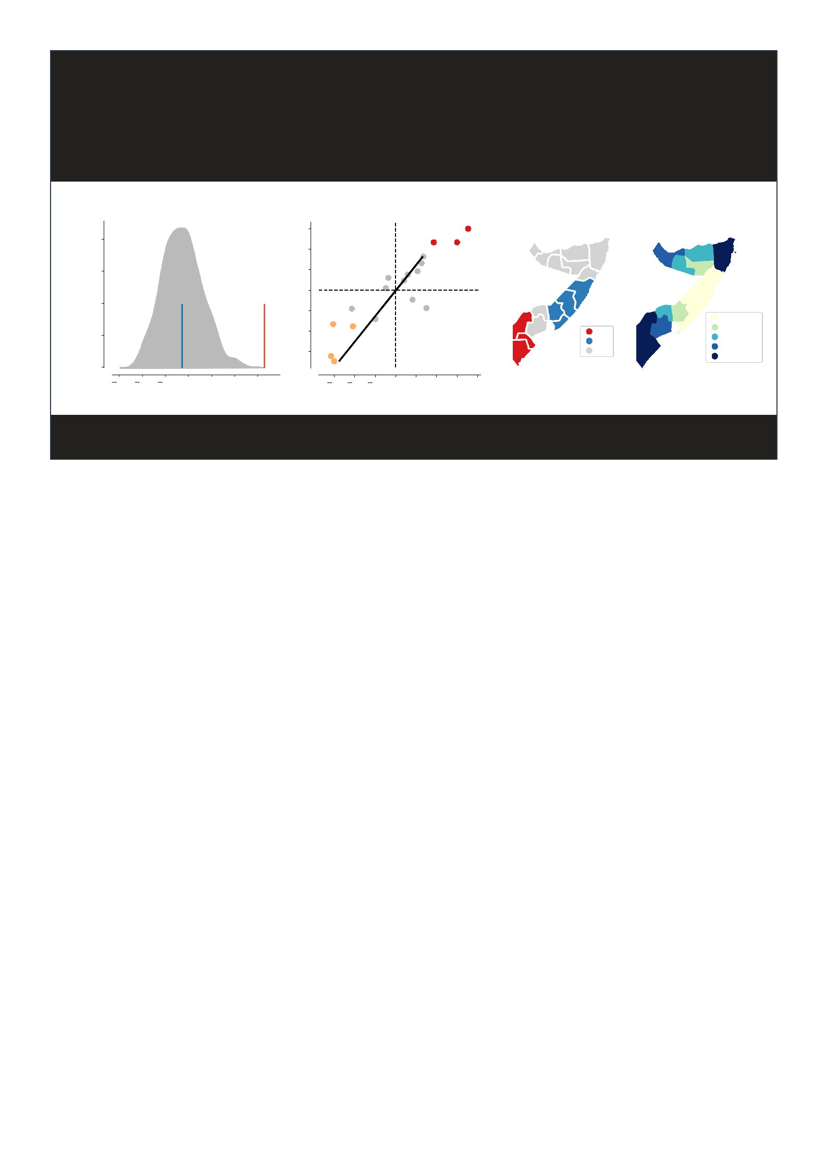

|  |  |  |  |  |  |  |  |  |  |  |  |  |  |  |  |  |  |
| --- | --- | --- | --- | --- | --- | --- | --- | --- | --- | --- | --- | --- | --- | --- | --- | --- | --- |
|  |  |  |  | SPATIAL AUTOCORRELATION | | | | | | | | | | | |  |  |
|  |  | Reference Distribution | | | | | |  | Moran Local scatterplot | | | | | | |  |  |
|  | 2.0 |  |  |  |  |  |  |  | 1.5 |  |  |  |  |  |  |  |  |
|  |  |  |  |  |  |  |  | 1.0 |  |  |  |  |  |  |  |  |
|  |  |  |  |  |  |  |  |  |  |  |  |  |  |  |  |  |
|  | 1.5 |  |  |  |  |  |  | Spatial Lag | 0.5 |  |  |  |  |  |  |  |  |
| Density | 1.0 |  |  |  |  |  |  | 0.0 |  |  |  |  |  |  |  |  |
|  |  |  |  |  |  | 0.5 |  |  |  |  |  |  |  |  |
|  |  |  |  |  |  |  |  |  |  |  |  |  | 0.32, 0.36 |  |
|  |  |  |  |  |  |  |  |  |  |  |  |  |  |  |
| 0.5 |  |  |  |  |  |  | 1.0 |  |  |  |  |  | HH | 0.36, 0.43 |  |
|  |  |  |  |  |  |  |  |  |  |  |  |  |  |
|  |  |  |  |  |  |  |  |  |  |  |  |  |  |  | 0.43, 0.48 |  |
|  |  |  |  |  |  |  |  |  |  |  |  |  |  |  | LL |  |
|  |  |  |  |  |  |  |  |  | 1.5 |  |  |  |  |  | 0.48, 0.50 |  |
|  |  |  |  |  |  |  |  |  |  |  |  |  |  | ns |  |
|  | 0.0 |  |  |  |  |  |  |  |  |  |  |  |  |  | 0.50, 0.58 |  |
|  |  |  |  |  |  |  |  |  |  |  |  |  |  |  |  |
|  |  |  |  |  |  |  |  |  |  |  |  |  |  |  |  |  |
|  | 0.6 | 0.4 | 0.2 | 0.0 | 0.2 | 0.4 | 0.6 |  | 1.5 | 1.0 | 0.5 | 0.0 | 0.5 | 1.0 | 1.5 |  |  |

Climate and conflicts in Somalia Pagina 7 di 12

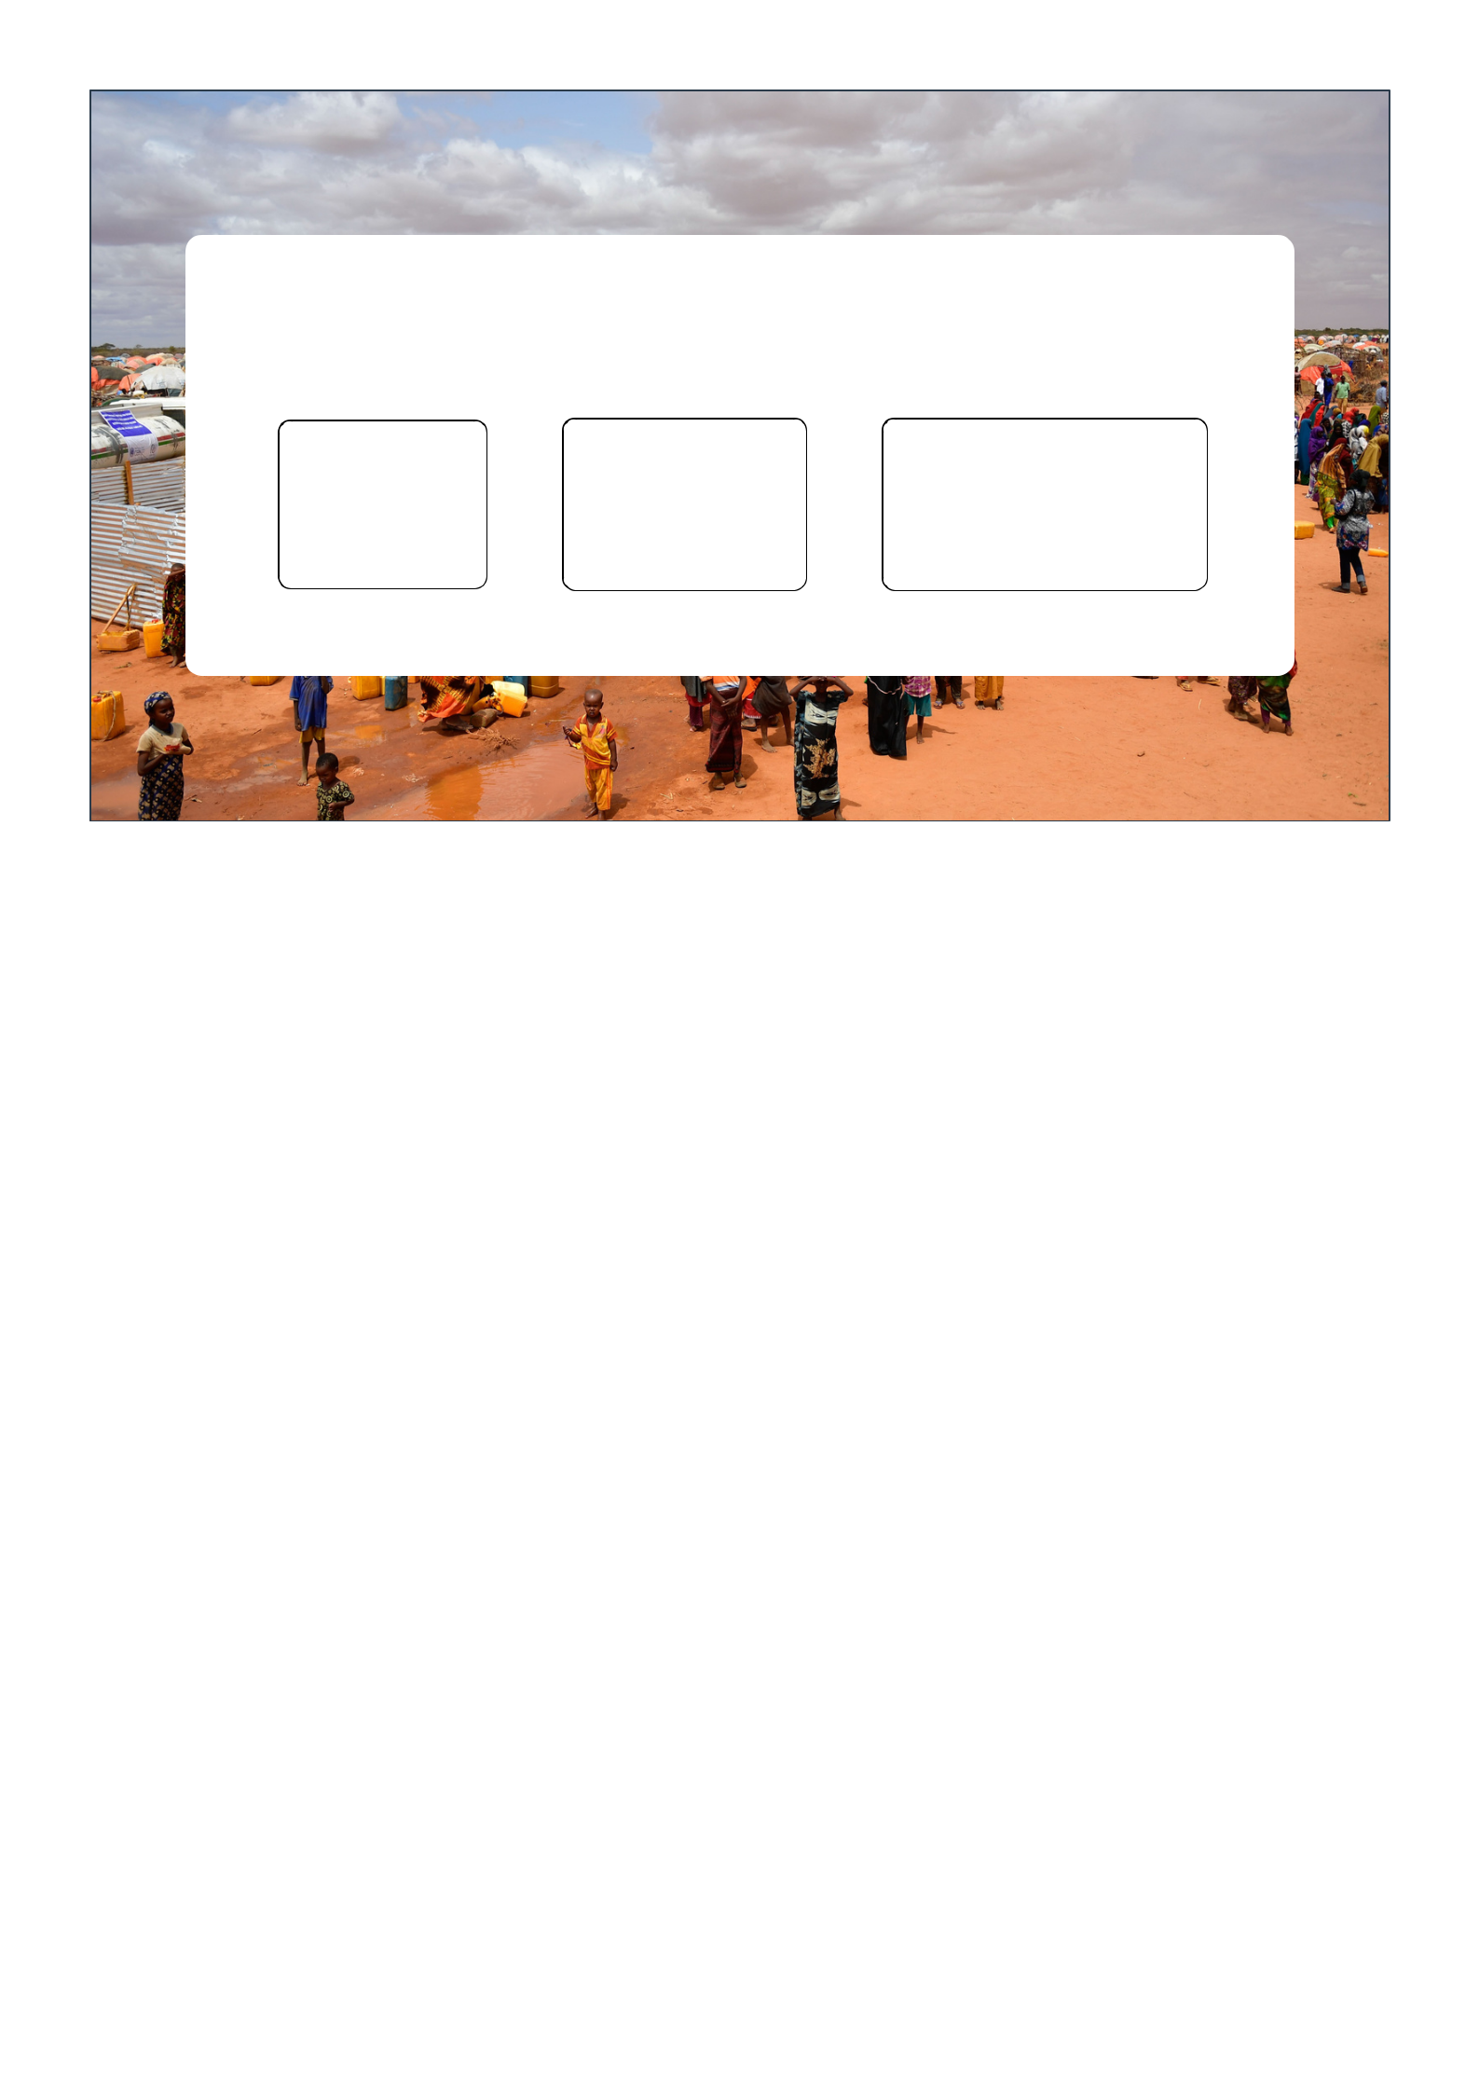

**MODELS**

|  |  |  |  |  |
| --- | --- | --- | --- | --- |
| **y = X** |  | **y = WX + X** |  | **y = WY + WX + X** |
|  |  |  |  |  |
| Linear |  | SLX |  | SDM |
|  |  |  |  |  |

Climate and conflicts in Somalia Pagina 8 di 12

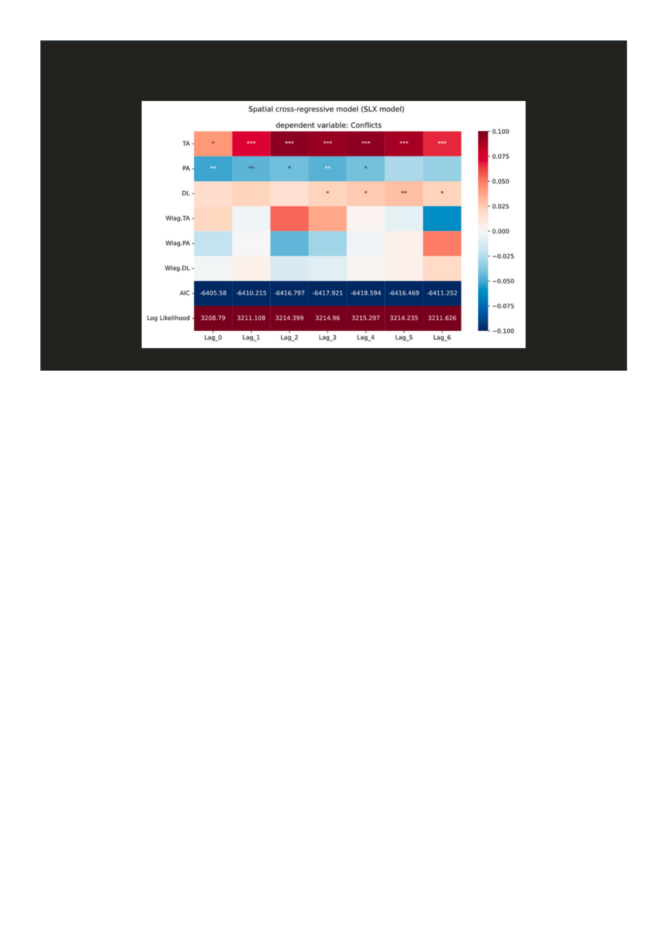**y = βX + Wlag.β WX**

Climate and conflicts in Somalia Pagina 9 di 12

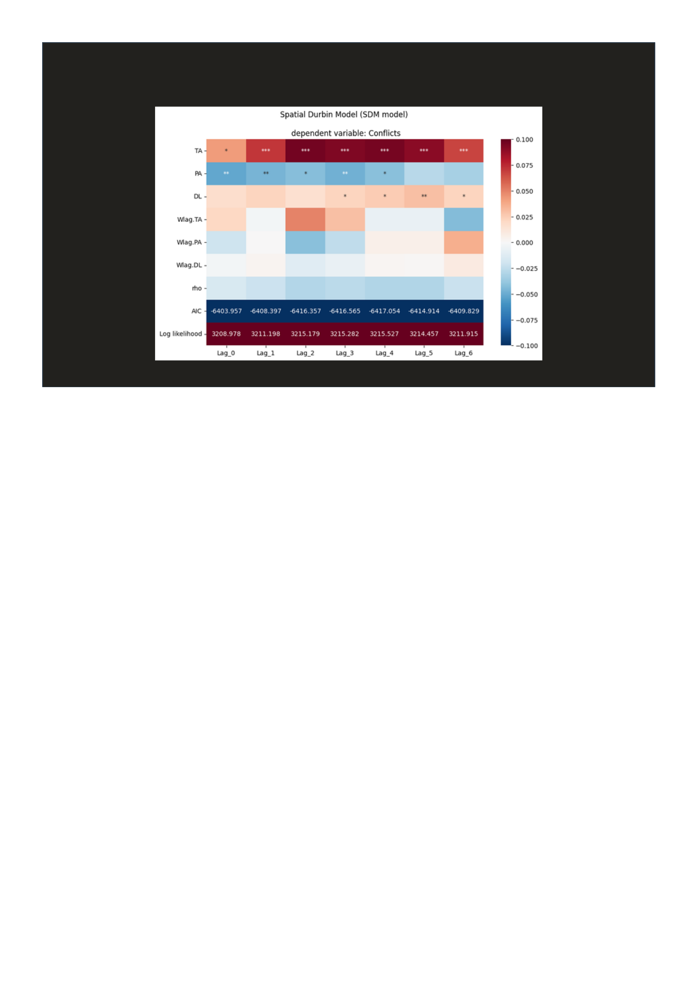**y = βX + Wlag.β WX + ρ WY**

Climate and conflicts in Somalia Pagina 10 di 12



Thanks to the team

Elisa Omodei, Eugenio Valdano,

Alberto Antonioni, Daniela Paolotti,

Kyriaki Kalimeri, Lorenzo Dall’Amico,

Rossano Schifanella

Climate and conflicts in Somalia Pagina 11 di 12

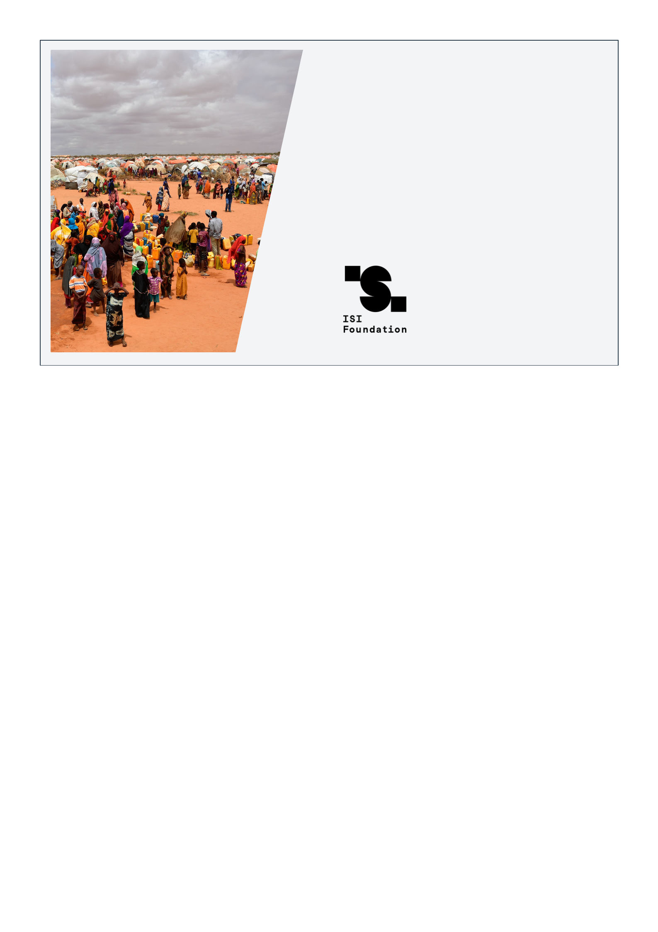

Thank you for

your attention

Sara Ghivarello

Climate and conflicts in Somalia Pagina 12 di 12